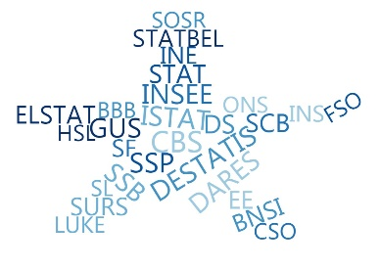

**ESSnet Big Data II**

**Grant Agreement Number: 847375-2018-NL-BIGDATA**

<https://webgate.ec.europa.eu/fpfis/mwikis/essnetbigdata>

[<https://ec.europa.eu/eurostat/cros/content/essnetbigdata_en>](https://ec.europa.eu/eurostat/cros/content/essnetbigdata_en)

**Workpackage WPB**

**Implementation – Online Job Vacancies**

**OJVs Web scraped from National Employment Agency Romania (RO) V.1.**

**Prepared by:**

**Ciprian Alexandru, Alin-Doru Cotirta, Andreea Racasanu (INS, Romania)**

**Date of present version: 20 August 2020**

Workpackage Leader:

Tomaž Špeh (SURS, SI)

e-mail address: tomaz.speh@gov.si

mobile phone: +38651672116

Contents

Potential indicators from OJVs calculated from web scraped data from National Employment Agency - Romania 4

Introduction 4

Web scraper 4

Data availability 4

Methodological considerations 5

Potential indicators from OJVs - Methodological framework V1 5

Results for Potential indicators from OJVs - Q4 2019 5

Dates and times of observations 5

Number of available on-line job vacancies in a reference day 5

Number of OJAs web scraped in a reference day by COR level 2 6

Number of OJVs web scraped in a reference day by required educational level 6

Number of OJAs web scraped in a reference day by CAEN 7

Number of OJAs web scraped in a reference day by Working Time 7

Number of OJAs web scraped in a reference day by Experience Years 8

Number of OJAs web scraped in a reference day by County 8

Number of OJAs web scraped in a reference day by Region Code 9

Number of OJAs web scraped in a reference day by Organization 9

Results for Potential indicators from OJVs - Q1 2020 10

Dates and times of observations 10

Number of available on-line job vacancies in a reference day 10

Number of OJAs web scraped in a reference day by COR level 2 10

Number of OJVs web scraped in a reference day by required educational level 11

Number of OJAs web scraped in a reference day by CAEN 11

Number of OJAs web scraped in a reference day by Working Time 12

Number of OJAs web scraped in a reference day by Experience Years 12

Number of OJAs web scraped in a reference day by County 13

Number of OJAs web scraped in a reference day by Region Code 13

Number of OJAs web scraped in a reference day by Organization 14

Results for Potential indicators from OJVs - Q2 2020 14

Dates and times of observations 14

Number of available on-line job vacancies in a reference day 14

Number of OJAs web scraped in a reference day by COR level 2 15

Number of OJVs web scraped in a reference day by required educational level 15

Number of OJAs web scraped in a reference day by CAEN 16

Number of OJAs web scraped in a reference day by Working Time 16

Number of OJAs web scraped in a reference day by Experience Years 17

Number of OJAs web scraped in a reference day by County 17

Number of OJAs web scraped in a reference day by Region Code 18

Number of OJAs web scraped in a reference day by Organization 18

# Potential indicators from OJVs calculated from web scraped data from National Employment Agency - Romania

## Introduction

In this material we present the results for computation of potential indicators of Online Job Vacancies from the web scraped site of the National Employment Agency from Romania, www.anofm.ro. Romanian law requires employers to declare jobs vacant.

“*To communicate to the county agency for employment, all vacancies, within 5 working days from their vacancy, by completing and submitting Annex 1A of the Methodological Norms for the application of Law no. 76/2002 on the unemployment insurance system and employment stimulation. They also have the obligation to communicate the filling of vacancies that were communicated, within one day from the date of their occupation, in accordance with the law, by completing and submitting Annex 1B of the Methodological Norms for the application of Law no. 76/2002 on the unemployment insurance system and employment stimulation.   
Through vacancies, according to Law no. 76/2002, are the jobs that became available as a result of the termination of the employment or service relations, as well as the newly created jobs.  
Employers who have employed, according to the law, persons among the beneficiaries of unemployment benefits have the obligation to notify within 3 days the employment agencies at which they were registered.*”

## Web scraper

The web scraper was build in R software and it is available online on GitHub.

<https://github.com/OnlineJobVacanciesESSnetBigData/romScrappers/blob/master/anofm.R>

## Data availability

The results presented in this material are calculated on the data colected on reference day of the Job Vacancies Survey, the last working day of the second month of the quarter. Therefore, the months in which the data were collected were Nov 2019, March 2020 (not Feb 2020, because on some technical issue) and May 2020.

The collected OJV were validated in order to be still available in the reference day.

## Methodological considerations

ESSNet II WPB OJV Methodological framework V1 [1]

# Potential indicators from OJVs - Methodological framework V1

Number of available on-line job vacancies in a reference day

Number of OJAs web scraped in a reference day by COR/ESCO level 2

Number of OJVs web scraped in a reference day by required educational level

Number of OJAs web scraped in a reference day by CAEN/NACE

Number of OJAs web scraped in a reference day by Working Time

Number of OJAs web scraped in a reference day by Experience Years

Number of OJAs web scraped in a reference day by County

Number of OJAs web scraped in a reference day by Region Code

Number of OJAs web scraped in a reference day by Organization

# Results for Potential indicators from OJVs - Q4 2019

## Dates and times of observations

The interval in which the OJVs are available (not expirated): 2019-11-29 - 2021-10-01.

## Number of available on-line job vacancies in a reference day

Data collected from National Employment Agency from Romania refers to all observations webscraped in the reference day of JVS from website www.anofm.ro, the last day of the second month of a quarter (November 2019).  
In the National Employment Agency database there are 9030 observations in the reference day.  
Of these, the total number of unique OJV is 9030.  
The total number of JVs posted in the National Employment Agency is 30085.  
The number of employers who posted the OJV is 4149.

## Number of OJAs web scraped in a reference day by COR level 2

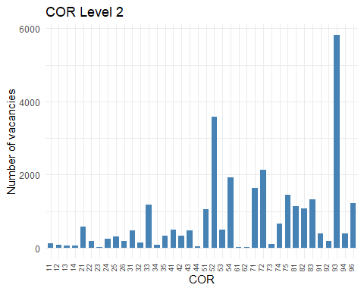

## Number of OJVs web scraped in a reference day by required educational level

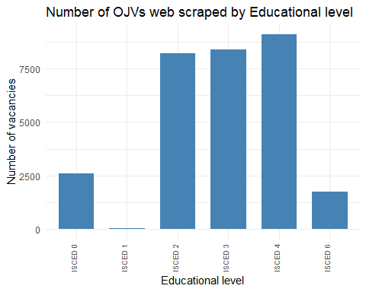

## Number of OJAs web scraped in a reference day by CAEN

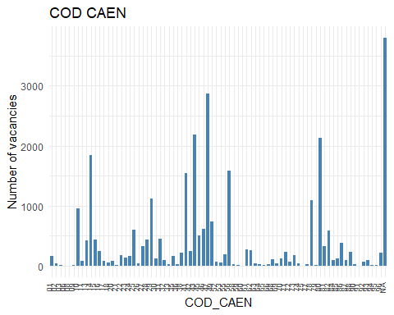

## Number of OJAs web scraped in a reference day by Working Time

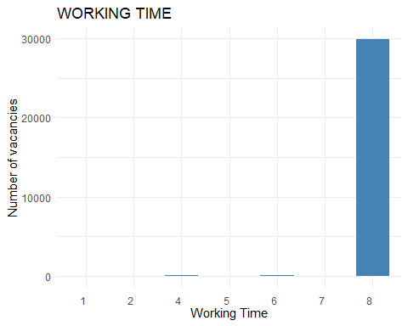

## Number of OJAs web scraped in a reference day by Experience Years

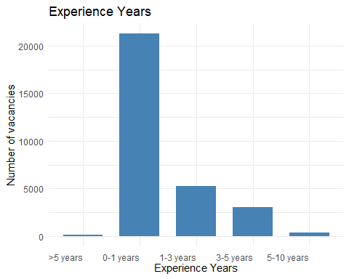

## Number of OJAs web scraped in a reference day by County

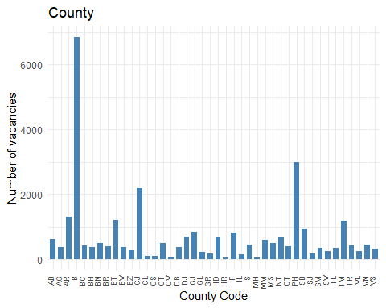

## Number of OJAs web scraped in a reference day by Region Code

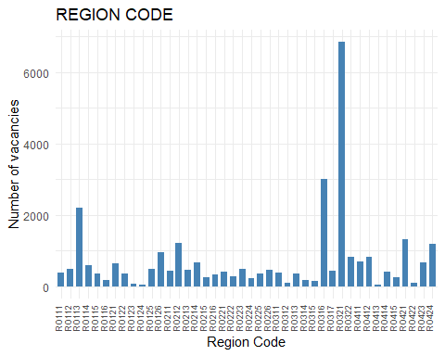

## Number of OJAs web scraped in a reference day by Organization

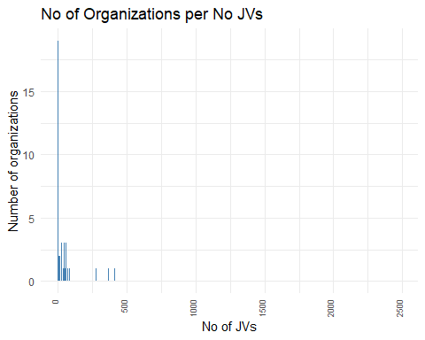

# Results for Potential indicators from OJVs - Q1 2020

## Dates and times of observations

The interval in which the OJVs are available (not expirated): 2020-03-29 - 2021-10-01.

## Number of available on-line job vacancies in a reference day

Data collected from National Employment Agency from Romania refers to all observations webscraped in the reference day of JVS from website www.anofm.ro, the last day of the second month of a quarter (March 2020).  
In the National Employment Agency database there are 7454 observations in the reference day.  
Of these, the total number of unique OJV is 7454.  
The total number of JVs posted in the National Employment Agency is 22030.  
The number of employers who posted the OJV is 3364.

## Number of OJAs web scraped in a reference day by COR level 2

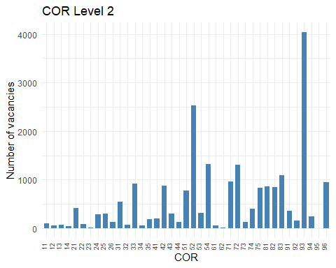

## Number of OJVs web scraped in a reference day by required educational level

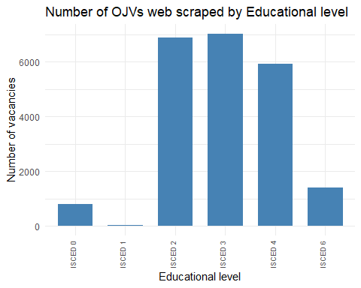

## Number of OJAs web scraped in a reference day by CAEN

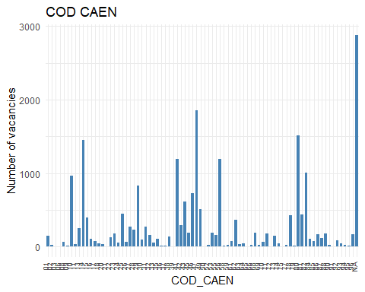

## Number of OJAs web scraped in a reference day by Working Time

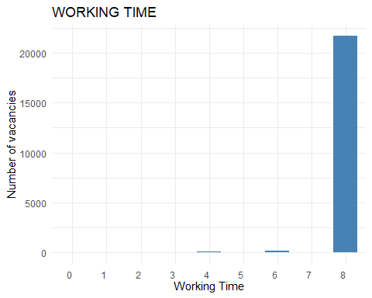

## Number of OJAs web scraped in a reference day by Experience Years

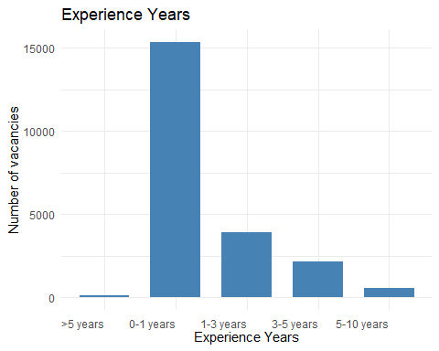

## Number of OJAs web scraped in a reference day by County

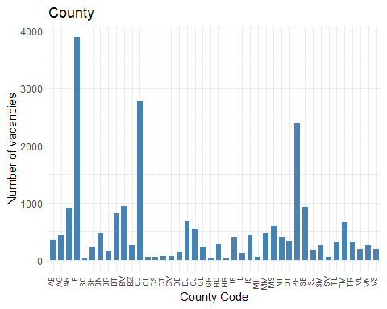

## Number of OJAs web scraped in a reference day by Region Code

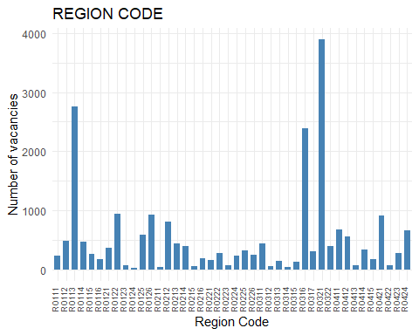

## Number of OJAs web scraped in a reference day by Organization

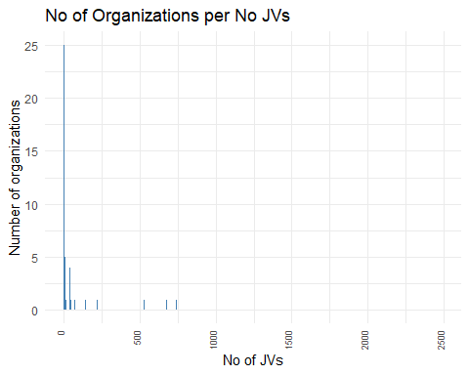

# Results for Potential indicators from OJVs - Q2 2020

## Dates and times of observations

The interval in which the OJVs are available (not expirated): 2020-06-01 - 2021-10-01.

## Number of available on-line job vacancies in a reference day

Data collected from National Employment Agency from Romania refers to all observations webscraped in the reference day of JVS from website www.anofm.ro, the last day of the second month of a quarter (May 2020).  
In the National Employment Agency database there are 4058 observations in the reference day.  
Of these, the total number of unique OJV is 4058.  
The total number of JVs posted in the National Employment Agency is 11130.  
The number of employers who posted the OJV is 2011.

## Number of OJAs web scraped in a reference day by COR level 2

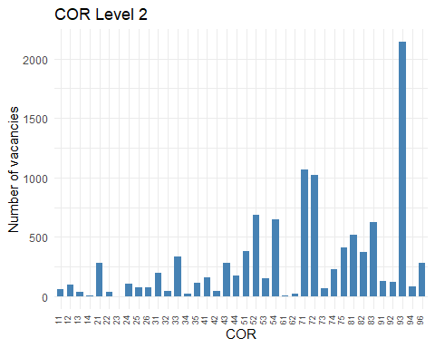

## Number of OJVs web scraped in a reference day by required educational level

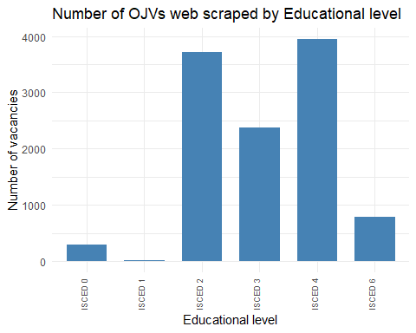

## Number of OJAs web scraped in a reference day by CAEN

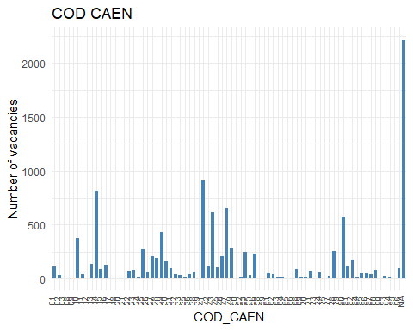

## Number of OJAs web scraped in a reference day by Working Time

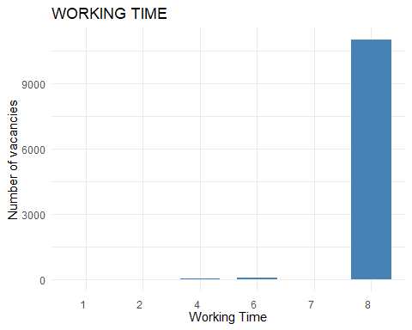

## Number of OJAs web scraped in a reference day by Experience Years

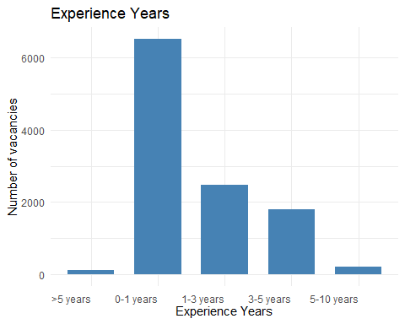

## Number of OJAs web scraped in a reference day by County

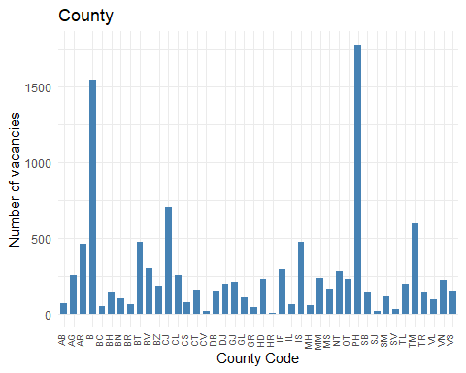

## Number of OJAs web scraped in a reference day by Region Code

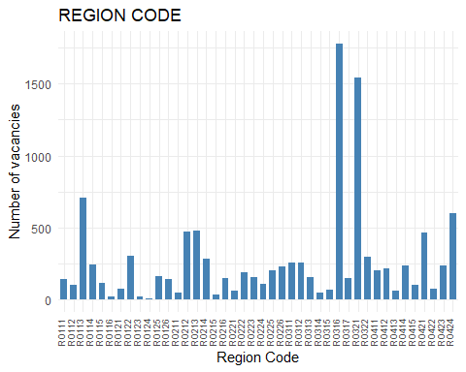

## Number of OJAs web scraped in a reference day by Organization

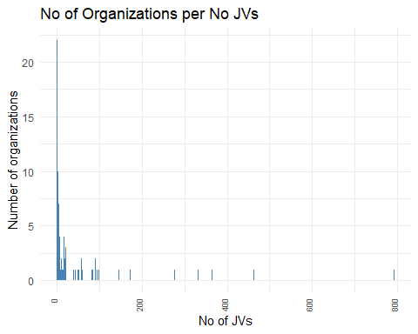

1. https://webgate.ec.europa.eu/fpfis/wikis/download/attachments/440405614/ESSNet%20II%20WPB%20OJV%20Methodological%20framework%20V1%2018032020_4.docx?version=1&modificationDate=1590989511103&api=v2